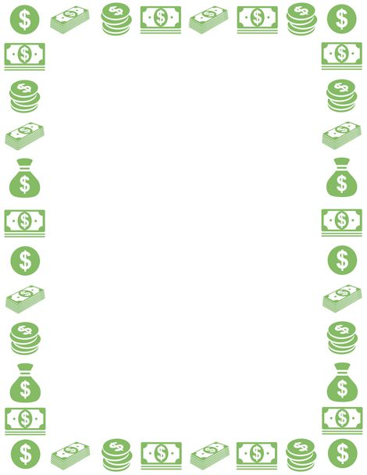

City of Canadian

2023-2024 Budget